Dependency Matrix

Row depends on Column | Game loop | State Management | Input Management | Sound | Scene Management | Create Menu Screens | Create Game Scene | State Specific Game Logic | Multi-Player | AI | Chat | Network management | Respond to Client Requests | Server Logger
Game loop
State Management | X
Input Management |  | X
Sound |  | X
Scene Management |  | X
Create Menu Screens |  |  | X |  | X
Create Game Scene |  |  |  |  | X
State Specific Game Logic |  |  |  |  |  | X | X | X
Multi-Player |  |  |  |  |  |  | X |  |  | X
AI |  | X |  |  |  |  | X
Chat |  |  |  |  |  |  |  |  |  | X
Network management |  |  |  |  |  |  |  |  |  |  |  |  |  | X
Respond to Client Requests |  |  |  |  |  |  |  |  |  |  |  | X
Server Logger

A good measure of complexity is the amount of dependencies that a certain work item has. In this case, State Specific Logic work is dependent upon The Creation of all the screens, this is due to the state machine transitions between them. The Scene Management, and State Creation and Specific State Logic are very interconnected and clustered. This inherently increases the complexity of the individual work items as there are many lines of data communication between them, lots logic around the same area.

Independent work items seem to have fewer direct dependencies and dependents. Chat and server Logger are good examples.

As the complexity increases there is a need to simplify the system to draw out the dependencies. Adding sub work items (deeper requirements) can simplify the dependency graph. The dependency graph will be a good map to structure our code; our architecture can follow from the dependency graph. It lets us get a good feel on how our application components will interact and how they should be structured within the program. Not only does the dependency graph let us know what our architecture will resemble, but will give us a map on how to complete the project; we will take care to plan and traverse the work item graph carefully so current work may always continue.

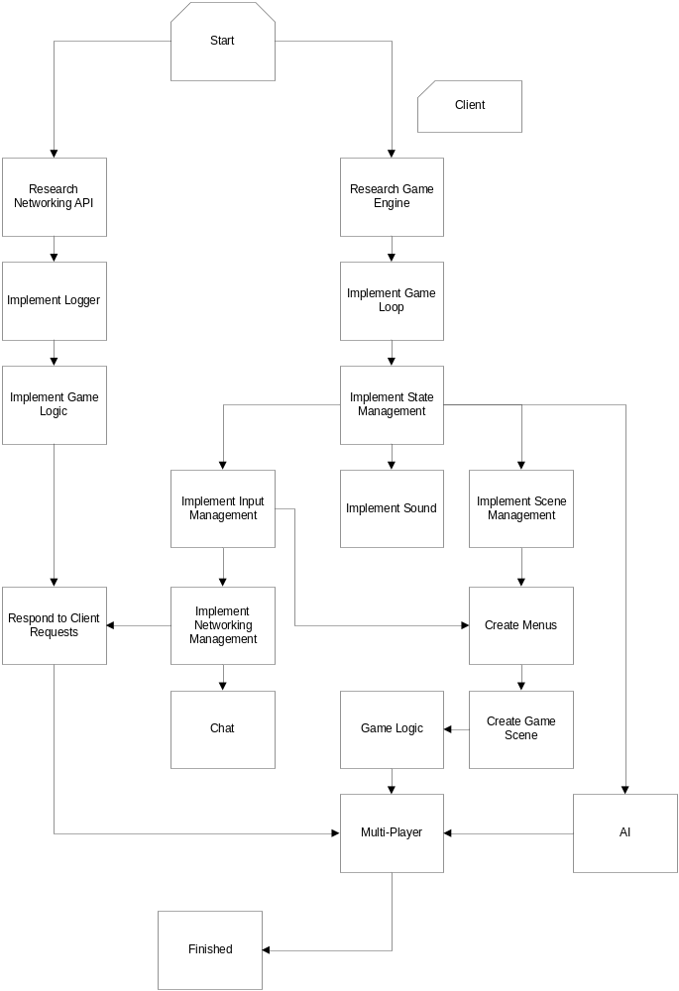
A dependency graph loosely representing the work item table.

